Cable Tester Application

# Introduction:

This document describes how to use and configure the cable tester application.

# Required equipment:

* Keithley 2100 Multimeter
* National Instruments USB-6509 DAQ
* Self Test adapter
* Cable Tester Fixture

# Required software:

National Instrument drivers for NI488, Visa and DAQMX

# Self Test:

Plug in the self test adapter into the test fixture.

Self test can either be performed by clicking the “self test” button at the bottom of the application or can be loaded using “File/Load” from the menu bar. The difference is, the self test can be modified with configuration files when using the “File/Load” method. The button just cycles through all the ports and binary combinations for each port.

# Testing cables:

Make sure all equipment is connected to the USB ports of the computer and powered on.

Plug the cable to be tested into the test fixture.

Select “File/Load” from the menu bar at the top of the application. Locate the limits file for the cable to be tested. The limits file will be prefixed with “lim ” and have a “.csv” extension. See figure below:

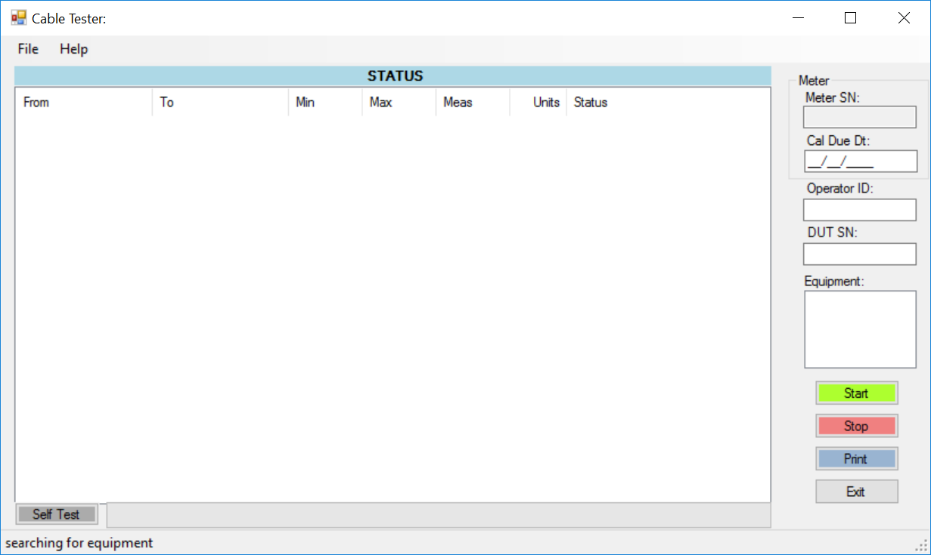

Figure 1

After selecting the limits file, you will see a list of tests appear in the status window (see figure 2 below). Enter the required information on the right of the form and click “Start”.

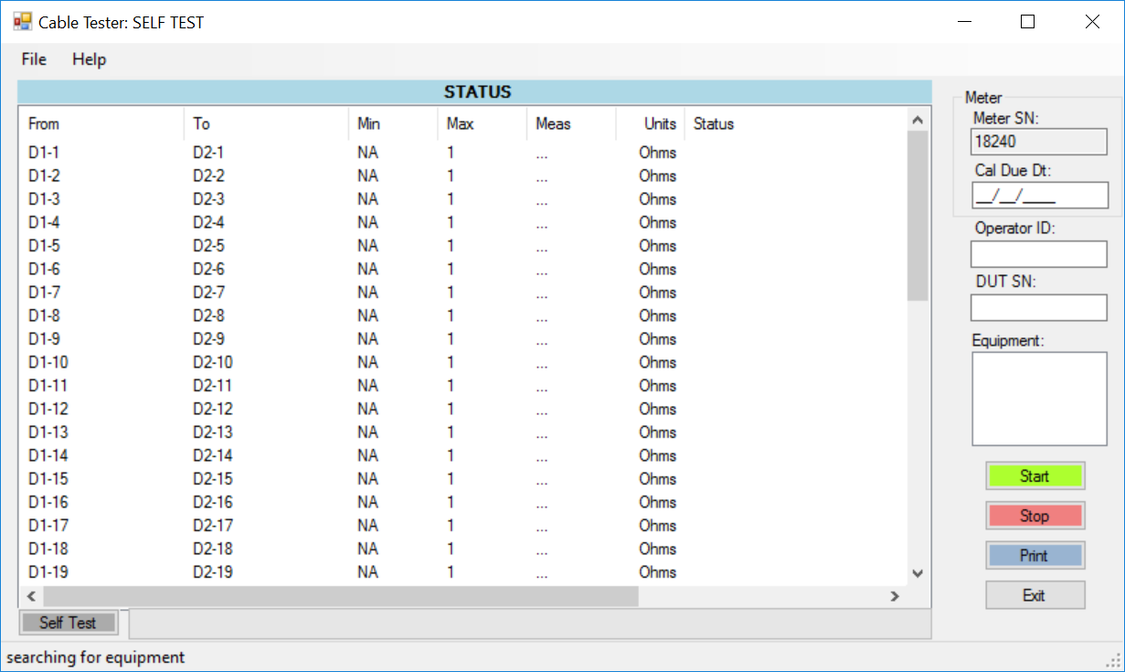

Figure 2

# Configuration files:

## Application Configuration:

The application configuration file is located in the application directory and is called “CableTesterConfig.txt”.

The file contains the “dataDir”, location of where data will be stored, and “NIDriversDir”, path to National Instrument drivers, settings.

**Example:**

dataDir = c:\cableTestdata

NIDriversDir=c:\Program Files (x86)\National Instruments\MeasurementStudioVS2010\DotNet\Assemblies\Current

## Limits File

The limits file contains the tests to be performed, along with the associated limits. The limits file is in comma separated format. The first five lines of the limits file contain the following:

//from,to,min,max,units,range,IO1,IO2,test method,precision

name= CUAS_SHORT,,,,,,,,,

meter sn=118240,,,,,,,,,

daqsn=13FC757 ,,,,,,,,,

mode=manual,,,,,,,,,

The remaining lines contain information for the tests. The first two elements in the lines, “from” and “to”, are switch settings, which come from the switch file containing the same name as the limits file, except prefixed with “sw” instead of “lim “.

## Switch File

The switch file contains the DAQ settings. Each line will contain only one setting. Each line contains a label, port number and eight bit binary setting for the port. The label is referenced in the limits file.

The first line of the file shall contain the following line:

AllOff=0,00000000;1,00000000;2,00000000;3,00000000;4,00000000;5,00000000;6,00000000;7,00000000;8,00000000;9,00000000;10,00000000;11,00000000

Example entry:

D1-1=1,10000000

Where “D1-1” is the entry, 1 is the port number and “10000000” is the eight bit setting for the port.

Ports 0-6 of the DAQ are dedicated to the top connector of the fixture, and ports 7-12 are dedicated to the bottom connector.

Performing a measurement typically would involve a port from each connector, such as:

Switch file has:

D1-1=1,10000000

D2-1=7,10000000

Limits file has:

D1-1,D2-1,NA,1,Ohms,MIN,NONE,NONE,resistance,3